Q1. Implement an OpenMP program to compute the sum of the first N natural numbers in parallel. Using the same program, demonstrate the effect of the following OpenMP data-sharing clauses:
- shared
- private
- firstprivate
- lastprivate
For each case:
- Execute the program.
- Observe the output produced.
- Explain the effect of the data-sharing clause on:
  - Variable values
  - Data accessibility among threads
  - Correctness of the final result
Finally, compare the outputs obtained for each data-sharing clause and explain why they differ.
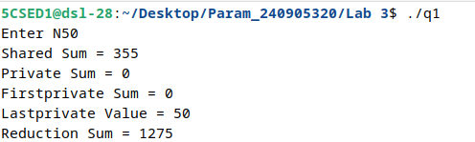

Q2. Implement a C program using OpenMP to process an integer array in parallel and demonstrate the use of the following synchronization constructs:
- critical
- atomic
- reduction
- master
The program should perform the following tasks:
- The master thread should initialize the array and display the total number of threads participating in the computation.
- Use the reduction clause to compute the sum of all array elements in parallel.
- Use the atomic construct to count the number of even elements in the array.
- Use the critical construct to allow each thread to safely display its thread ID and the partial sum of the array elements processed by that thread.
- After all threads complete execution, the master thread should display the final sum of the array elements and the total count of even numbers.

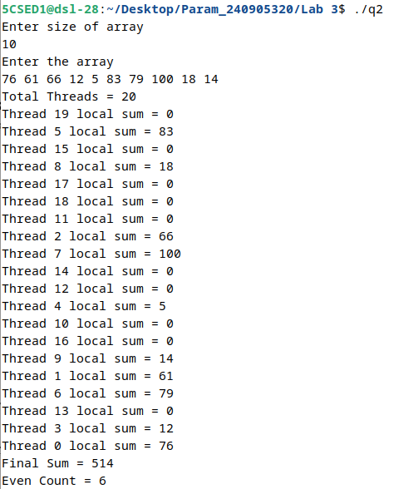

Q3. Implement an OpenMP program using C to determine the number of prime numbers within a given range (1 to N) using the parallel for directive. Since checking whether a number is prime requires a varying amount of computation depending on the number being tested, this problem exhibits an imbalanced workload across loop iterations.
Execute the program separately using the following OpenMP scheduling policies:
- schedule(static)
- schedule(dynamic)
- schedule(guided)
For each scheduling policy:
- Record the thread ID responsible for processing each number.
- Measure the execution time using omp_get_wtime().
- Observe how loop iterations are distributed among the threads.
- Compare the load balancing and execution time obtained with each scheduling policy.
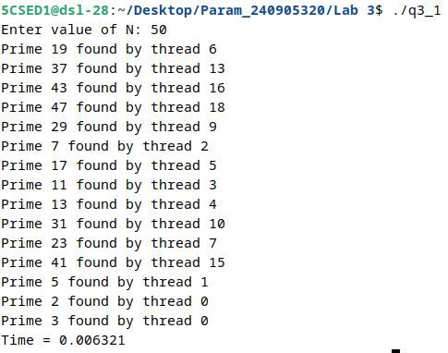
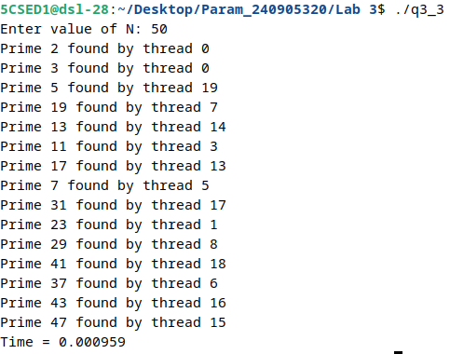
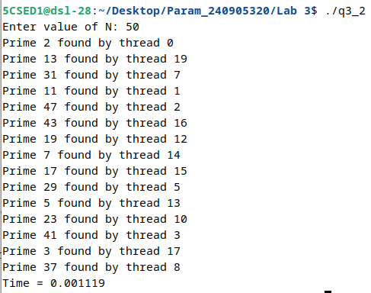
Q4. Write a parallel program using OpenMP to implement the Merge Sort algorithm.
Analyze the performance by computing:
- Sequential execution time
- Parallel execution time
- Speedup
- Efficiency
Perform the analysis for varying input sizes and thread counts.
